Step 1: Install Apache

Apache is available within Ubuntu's default software repositories, so we will install it using conventional package management tools.

We will begin by updating the local package index to reflect the latest upstream changes. Afterwards, we can install the apache2 package:

* sudo apt-get update
* sudo apt-get install apache2

After confirming the installation, apt-get will install Apache and all required dependencies.

Step 2: Adjust the Firewall

Before we can test Apache, we need to modify our firewall to allow outside access to the default web ports. Assuming that you followed the instructions in the prerequisites, you should have a UFW firewall configured to restrict access to your server.

During installation, Apache registers itself with UFW to provide a few application profiles. We can use these profiles to simplify the process of enabling or disabling access to Apache through our firewall.

We can list the ufw application profiles by typing:

* sudo ufw app list

You should get a listing of the application profiles:

Output

Available applications:

Apache

Apache Full

Apache Secure

OpenSSH

As you can see, there are three profiles available for Apache:

* **Apache**: This profile opens only port 80 (normal, unencrypted web traffic)
* **Apache Full**: This profile opens both port 80 (normal, unencrypted web traffic) and port 443 (TLS/SSL encrypted traffic)
* **Apache Secure**: This profile opens only port 443 (TLS/SSL encrypted traffic)

For our purposes, we will allow incoming traffic for the **Apache Full** profile by typing:

* sudo ufw allow 'Apache Full'

You can verify the change by typing:

* sudo ufw status

You should see HTTP traffic allowed in the displayed output:

Output

Status: active

To Action From

-- ------ ----

OpenSSH ALLOW Anywhere

Apache Full ALLOW Anywhere

OpenSSH (v6) ALLOW Anywhere (v6)

Apache Full (v6) ALLOW Anywhere (v6)

As you can see, the profile has been activated to allow access to the web server.

Step 3: Check your Web Server

At the end of the installation process, Ubuntu 16.04 starts Apache. The web server should already be up and running.

We can check with the systemd init system to make sure the service is running by typing:

* sudo systemctl status apache2

Output

● apache2.service - LSB: Apache2 web server

Loaded: loaded (/etc/init.d/apache2; bad; vendor preset: enabled)

Drop-In: /lib/systemd/system/apache2.service.d

└─apache2-systemd.conf

Active: active (running) since Fri 2017-05-19 18:30:10 UTC; 1h 5min ago

Docs: man:systemd-sysv-generator(8)

Process: 4336 ExecStop=/etc/init.d/apache2 stop (code=exited, status=0/SUCCESS)

Process: 4359 ExecStart=/etc/init.d/apache2 start (code=exited, status=0/SUCCESS)

Tasks: 55

Memory: 2.3M

CPU: 4.094s

CGroup: /system.slice/apache2.service

├─4374 /usr/sbin/apache2 -k start

├─4377 /usr/sbin/apache2 -k start

└─4378 /usr/sbin/apache2 -k start

May 19 18:30:09 ubuntu-512mb-nyc3-01 systemd[1]: Stopped LSB: Apache2 web server.

May 19 18:30:09 ubuntu-512mb-nyc3-01 systemd[1]: Starting LSB: Apache2 web server...

May 19 18:30:09 ubuntu-512mb-nyc3-01 apache2[4359]: * Starting Apache httpd web server apache2

May 19 18:30:09 ubuntu-512mb-nyc3-01 apache2[4359]: AH00558: apache2: Could not reliably determine the server's fully qualified domain name, using 127.0.1.1. Set the 'ServerName' directive globally to suppress this message

May 19 18:30:10 ubuntu-512mb-nyc3-01 apache2[4359]: *

May 19 18:30:10 ubuntu-512mb-nyc3-01 systemd[1]: Started LSB: Apache2 web server.

As you can see above, the service appears to have started successfully. However, the best way to test this is to actually request a page from Apache.

You can access the default Apache landing page to confirm that the software is running properly. You can access this through your server's domain name or IP address.

If you are using DigitalOcean and do not have a domain name set up for your server, you can follow our guide [how to set up a domain with DigitalOcean](https://digitalocean.com/community/articles/how-to-set-up-a-host-name-with-digitalocean) to set one up.

If you do not want to set up a domain name for your server, you can use your server's public IP address. If you do not know your server's IP address, you can get it a few different ways from the command line.

Try typing this at your server's command prompt:

* hostname -I

You will get back a few addresses separated by spaces. You can try each in your web browser to see if they work.

An alternative is typing this, which should give you your public IP address as seen from another location on the internet:

* sudo apt-get install curl
* curl -4 icanhazip.com

When you have your server's IP address or domain, enter it into your browser's address bar:

http://server_domain_or_IP

You should see the default Ubuntu 16.04 Apache web page, which should look something like this:

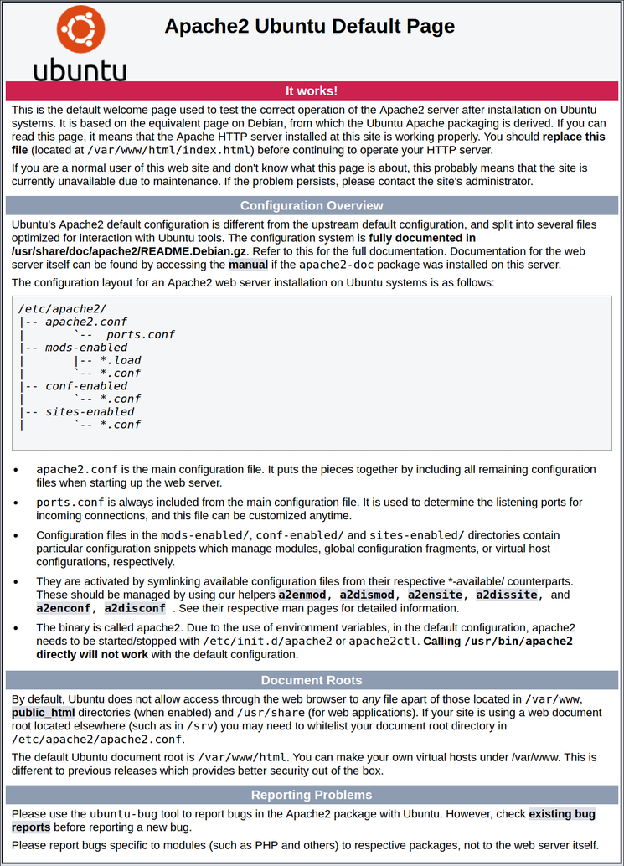

This page is simply included to show that Apache is working correctly. It also includes some basic information about important Apache files and directory locations.

Step 4: Manage the Apache Process

Now that you have your web server up and running, we can go over some basic management commands.

To stop your web server, you can type:

* sudo systemctl stop apache2

To start the web server when it is stopped, type:

* sudo systemctl start apache2

To stop and then start the service again, type:

* sudo systemctl restart apache2

If you are simply making configuration changes, Apache can often reload without dropping connections. To do this, you can use this command:

* sudo systemctl reload apache2

By default, Apache is configured to start automatically when the server boots. If this is not what you want, you can disable this behavior by typing:

* sudo systemctl disable apache2

To re-enable the service to start up at boot, you can type:

* sudo systemctl enable apache2

Apache should now start automatically when the server boots again.

Step 5: Get Familiar with Important Apache Files and Directories

Now that you know how to manage the service itself, you should take a few minutes to familiarize yourself with a few important directories and files.

**Content**

* /var/www/html: The actual web content, which by default only consists of the default Apache page you saw earlier, is served out of the /var/www/html directory. This can be changed by altering Apache configuration files.

**Server Configuration**

* /etc/apache2: The Apache configuration directory. All of the Apache configuration files reside here.
* /etc/apache2/apache2.conf: The main Apache configuration file. This can be modified to make changes to the Apache global configuration. This file is responsible for loading many of the other files in the configuration directory.
* /etc/apache2/ports.conf: This file specifies the ports that Apache will listen on. By default, Apache listens on port 80 and additionally listens on port 443 when a module providing SSL capabilities is enabled.
* /etc/apache2/sites-available/: The directory where per-site "Virtual Hosts" can be stored. Apache will not use the configuration files found in this directory unless they are linked to the sites-enabled directory (see below). Typically, all server block configuration is done in this directory, and then enabled by linking to the other directory with the a2ensite command.
* /etc/apache2/sites-enabled/: The directory where enabled per-site "Virtual Hosts" are stored. Typically, these are created by linking to configuration files found in the sites-available directory with the a2ensite. Apache reads the configuration files and links found in this directory when it starts or reloads to compile a complete configuration.
* /etc/apache2/conf-available/, /etc/apache2/conf-enabled/: These directories have the same relationship as the sites-available and sites-enabled directories, but are used to store configuration fragments that do not belong in a Virtual Host. Files in the conf-available directory can be enabled with the a2enconf command and disabled with the a2disconf command.
* /etc/apache2/mods-available/, /etc/apache2/mods-enabled/: These directories contain the available and enabled modules, respectively. Files in ending in .load contain fragments to load specific modules, while files ending in .conf contain the configuration for those modules. Modules can be enabled and disabled using the a2enmod and a2dismod command.

**Server Logs**

* /var/log/apache2/access.log: By default, every request to your web server is recorded in this log file unless Apache is configured to do otherwise.
* /var/log/apache2/error.log: By default, all errors are recorded in this file. The LogLeveldirective in the Apache configuration specifies how much detail the error logs will contain.